**WELCOME**

**TO**

**OPJS CENTRAL LIBRARY**

**Please Scan Code for OPAC Library Please Scan Code for Digital Library**

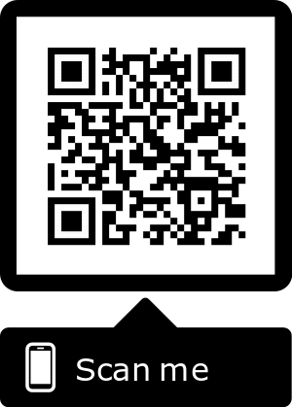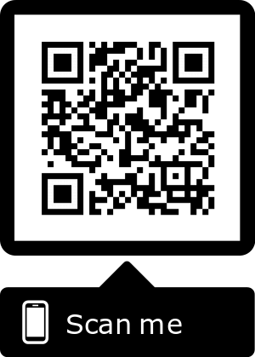

** OPJS OPAC Library OPJS Digital Library**

**oo**

**LIBRARY**

